Management Plan for
Antarctic Specially Protected Area No. 140

PARTS OF DECEPTION ISLAND,
SOUTH SHETLAND ISLANDS

1. Description of values to be protected

Deception Island (latitude 62º57’S, longitude 60º38’W) is an active volcano. Recent eruptions occurring in 1967, 1969 and 1970 (Baker et al. 1975) altered many of the topographical features of the island and created new, and locally transient, surfaces for the colonisation of plants and other terrestrial biota (Collins 1969, Cameron & Benoit 1970, Lewis Smith 1984a, b). There are a number of sites of geothermal activity, some with fumaroles (Smellie et al. 2002).

The flora of the island is unique in Antarctic terms, particularly where associated with these geothermal areas, but also because of the recently formed surfaces which provide known-age habitats for the study of colonisation and other dynamic ecological processes by terrestrial organisms (Lewis Smith 1988).

Five small sites around the coast of Port Foster were adopted under Recommendation XIII–8 (ATCM XIII, Brussels, 1985) as Site of Special Scientific Interest No. 21 on the grounds that “Deception Island is exceptional because of its volcanic activity, having had major eruptions in 1967, 1969 and 1970. Parts of the island were completely destroyed, new areas were created, and others were covered by varying depths of ash. Few areas of the interior were unaffected. The island offers unique opportunities to study colonization processes in an Antarctic environment”.

Following a detailed botanical survey of the island in 2002, the values specified in the original designation were reaffirmed and considerably augmented. The survey identified 11 sub-sites of unique botanical interest.

Those interests were:

- The island has the greatest number of rare and extremely rare plant species of any site in the Antarctic. 28 of the 54 mosses recorded on the island, 4 of the 8 liverworts and 14 of the ca. 75 lichen are considered to be rare or extremely rare. Appendix A lists the plant species classed as rare or extremely rare in the Antarctic Treaty Area, which occur on Deception Island. These represent 25%, 17% and ca. 4% of the total number of mosses, liverworts and lichens, respectively, known from the Antarctic (Aptroot & van der Knaap 1993, Bednarek-Ochyra et al. 2000, Ochyra et al. in press, Øvstedal & Lewis Smith 2001). 13 species of moss (including two endemics), 2 species of liverwort and 3 species of lichen growing on Deception Island have not been recorded elsewhere in the Antarctic. No other site in the Antarctic is comparable. This suggests that there is a significant deposition of immigrant propagules (by wind and seabirds), particularly of southern South American provenance, over the Antarctic, which becomes established only where favourable germinating conditions prevail (e.g. the heat and moisture provided around fumaroles) (Lewis Smith 1984a, b). Such sites are unique in the Antarctic Treaty Area.

- The more stable geothermal areas, some of which have fumaroles issuing steam and sulphurous gas, have developed bryophyte communities of varying complexity and density, each with a distinct and unique flora. Most of these areas were created during the 1967-70 series of eruptions, but at least one (Mt. Pond) predates that period. Species growing close to active vents are continuously subjected to temperatures between 30ºC to 50ºC, thereby posing important questions regarding their physiological tolerance.

- Areas of volcanic ash, mudflows, scoria and lapilli deposited between 1967 and 1970 provide unique known-age surfaces. These are currently being colonised by vegetation and other terrestrial biota, allowing the dynamics of immigration and colonisation to be monitored. These areas are unstable and subject to wind and water erosion, so exposing some areas to continual surface change and a cycle of re-colonisation.

- Kroner Lake, the only intertidal lagoon with hot springs in Antarctica, supports a unique community of brackish-water algae.

- Several sites within the Area, unaffected by ash deposits during the 1967-70 eruptions, support long-established mature communities with diverse vegetation and are typical of the older stable ecosystems on the island.

- The largest known stand of Antarctic pearlwort (Colobanthus quitensis), one of only two flowering plants in the Antarctic, is located within the Area. After being virtually eradicated by burial in ash during the 1967 eruption, it has recovered and is now spreading at an unprecedented rate within and beyond the original site. This correlates with the current trend in regional climate change, particularly increasing temperature.

2. Aims and objectives

Management of the Area aims to:

- preserve each site for its potential scientific research value, particularly monitoring floristic and ecological change, colonisation processes and community development;
- avoid degradation of the botanical, vulcanological, or geomorphological values of the Area by preventing unnecessary human disturbance;
- minimise potential conflicts of interest within the Area between scientists of different disciplines (e.g. biologists and vulcanologists), and between scientists and tourists;
- minimise the possibility of the introduction of alien plants and other biota to the Area by human activities;
- ensure that the flora is not adversely affected by excessive sampling within the Area;
- allow research within the Area of a compelling scientific nature which cannot be served elsewhere, and which is consistent with the objectives of this Management Plan;
- allow visits for management purposes and to resurvey the state of the botanical values for which each site has been designated, in support of the aims of this Management Plan.

3. Management activities

The following management activities shall be undertaken to protect the values of the Area:

- each of the botanical sub-sites shall be clearly marked with signs and boundary markers, where practicable;
- visits shall be made as necessary to assess whether the individual sites continue to serve the purposes for which they were designated and to ensure management and maintenance measures are adequate;
- markers, signs or other structures erected within each site for scientific or management purposes shall be secured and maintained in good condition, and removed when no longer necessary;
- equipment or materials shall be removed from the sites once no longer required;
- a map showing the location of each sub-site on Deception Island (stating any special restrictions that apply) shall be displayed prominently at Gabriel de Castilla Station (Spain) and Decepción Station (Argentina). Copies of the Management Plan shall be freely available and carried aboard all vessels planning visits to the island.

4. Period of designation

Designated for an indefinite period.

5. Maps

Figure 1 Antarctic Specially Protected Area No.140, Deception Island, showing the location of sub-sites A – L (Scale 1:100 000).
Figures 1a–d Topographic Maps of Antarctic Specially Protected Area No.140 showing sub-sites A- L (Scale 1: 25 000).

6. Description of the Area

6 (i) Geographical coordinates, boundary markers and natural features
The Area comprises 11 sub-sites, shown in Maps 1 and 1a-1d. This fragmented distribution is characteristic of the vegetation cover of Deception Island. Because of the patchy nature of stable and moist substrata not subjected to erosion, the vegetation has a very disjunct distribution and is consequently restricted to widely scattered, and often very small, habitats.

The sub-sites are lettered A to L (but excluding I), in a clockwise direction from the south-west of the caldera and referred to by the most prominent named geographical feature associated with each Site.

Site A - Collins Point The north-facing slopes between Collins Point and the unnamed point 1.15 km to the east (0.6 km west of Entrance Point), directly opposite Fildes Point, and extending from the back of the beach to a ridge from 0.5 and 1 km inland from the shoreline. The eastern boundary of Site A runs due south from the shore, following the outline of a ridge to an elevation of 184 m. The western boundary extends from Collins Point, following a ridge due south to an elevation of 145 m. The southern boundary follows the arcuate ridge crest running from east to west, following a line of summits (172, 223 and 214 m) joining points 184 and 145 m. The beach area, including the Collins Point light beacon (maintained by the Chilean Navy), to the 10 m contour is excluded from the site.

The site contains some of the best examples of the island’s longest established vegetation, largely unaffected by the recent eruptions, with high species diversity and several Antarctic rarities, some in considerable abundance. A few small plants of Colobanthus quitensis have very recently become established, while the large liverwort Marchantia berteroana is a fairly recent and spreading colonist.

Site B - Crater Lake This site extends from the foot of the northern slope of the broad valley ca. 300 m north of Crater Lake to the slope ca. 300 m south of the south side of the lake, including the lake, to the ridge lines of the crater ca. 50 m to the west and east of the lake, and lower scree ca. 10 m south of the shoreline at the south-west corner of the Site. The principal area of botanical interest lies on a scoria-covered lava tongue above the south-east of the lake, up to the 50 m contour. The site was unaffected by the recent eruptions.

The extensive, virtually monospecific, moss carpet (Sanionia uncinata), on the floor of the northern valley, is one of the largest continuously vegetated stands on the island. The vegetation on the scoria tongue has a diverse cryptogamic flora, including several Antarctic rarities, and exceptional development of turf-forming moss, dominated by one relatively common species (Polytrichastrum alpinum). Of particular interest is that it reproduces sexually in great abundance here. Sporophytes of this species are not known in such profusion in this, or any other moss, anywhere else in the Antarctic.

Site C - Unnamed hill, southern end of Fumarole Bay A narrow line of fumaroles extending ca. 30-40 x 3 m along the gently sloping summit ridge at ca. 105-107 m elevation on the unnamed hill above the north-west side of the unnamed intertidal lagoon northwest of Decepción Station (Argentina) at the southern end of Fumarole Bay. Commencing 10 m WNW of the summit cairn, the site extends in a rectangular strip along the ridge crest 5 m beyond the outermost fumaroles all around the Site. Access to the cairn is not restricted.

Several rare species of moss, some unique to the island, colonise the heated soil crust close to the line of vents.

Site D - Fumarole Bay The unstable moist scree slopes below the precipitous lava cliffs on the east side of the southern end of Stonethrow Ridge to the break of slope beyond the beach west of mid-Fumarole Bay. The site has a complex geology and contains the most diverse flora on the island, including several Antarctic rarities. It was unaffected by the recent eruptions.

The southern boundary of the site extends from a prominent massive yellow tuff boulder at the back of the beach above a shallow pool, westwards to the foot of the southernmost yellowish tuff cliff face above central Fumarole Bay. The eastern boundary runs northwards along the break-of-slope at the back of the beach for 1 km to a prominent outcrop of grey lava just north of a crimson lava cliff. The northern boundary extends from this point westwards to the foot of the Stonethrow Ridge cliffs. The western boundary follows the 75 m contour. The flat beach area from the shore, including a prominent inter-tidal fumarole, to the break-of-slope is excluded from the site.

Site E - West Stonethrow Ridge The site is a red scoria cone lying at ca. 270 m altitude, ca. 600 m south-south-west of the highest point on Stonethrow Ridge (330 m), west of central Fumarole Bay. It comprises two parts, each with fumaroles, the total area covering about 400 m². The boundary extends to 5 m beyond all evidence of geothermal activity.

This site possesses several very rare mosses, liverworts and lichens, two of the dominant species being a liverwort (Clasmatocolea grandiflora) and lichen (Stereocaulon condensatum), neither of which is known elsewhere in Antarctica. Photographs taken in the mid-1980s indicate that the development and diversity of this vegetation has advanced considerably. A skua nest (also noted in 1993) occupies the main site. These birds may be responsible for introducing some of the plants from Tierra del Fuego, notably the dominant liverwort.

Site F - Telefon Bay The site extends from the north shore of the lagoon at the south-west of Telefon Bay to the south of the "new island" hill, northwards to the north shoreline of the large unnamed lake at the northern end of Telefon Bay, and thence to the shore of the bay following approximately the 10 m contour of a low north-south trending ridge. The north-western boundary is 20 m from the break-of-slope below the prominent low cliff of crimson lava; this allows an access route skirting around the west and southern end of the larger of the two lakes.

This site incorporates several features created during the 1967 eruption in Telefon Bay, and includes the low flat land extending from the prominent hill on the south-eastern side to the steep slopes and lava outcrops ca. 0.5 km inland to the steep slope and lava cliffs below the north-eastern end of Stonethrow Ridge. The hill was created as a new island in 1967, but is now joined to the main island by the aforementioned ash plain. About 0.5 km north of the lagoon in the south-west of Telefon Bay there is a small shallow lake, while at the northern end of the plain there is a large deep lake. This lake is separated from the sea in Port Foster by a ca. 50 m long isthmus barely 2 m high and 2 m wide. It has been used as the main pedestrian access along this part of coastline, and is extremely vulnerable to erosion. If it is breached it will be quickly eroded further by high tides and storms, allowing the lake to become inter-tidal and profoundly altering its geochemistry and microbiota. The shoreline of Telefon Bay is excluded to allow access past the site.

The main feature of botanical interest is that all surfaces within the site date from 1967, thereby allowing accurate monitoring of colonisation by plants and other biota. The site has a generally barren appearance, but close inspection reveals an abundance of inconspicuous mosses and lichens. In the absence of geothermal activity here, colonisation processes may be related to aspects of the current trend in climate change. Although species diversity is low, the developing communities are typical of non-heated habitats throughout the island.

Site G - Pendulum Cove The site comprises the very uneven gentle slope of very coarse grey, crimson, red scoria and occasional disintegrating blocks of yellowish tuff overlying a dead glacier, due east of Crimson Hill and ca. 0.5-0.8 km south-east of Pendulum Cove. It extends ca. 500 m uphill, from west to east and from ca. 50 to 100 m altitude, and is ca. 500 m wide. It was created largely by the 1969 eruption. Geothermal activity was recorded during a survey in 1987, with substantial heat being emitted from crevices amongst scoria. There was no such evidence in 2002.

The Site boundary encloses the undulating “plateau”, an area of ca. 0.25 km². There are no natural features to delineate this area, but the boundary follows the break-of-slope between the plateau and the steep slopes rising to it.

Although vegetation is very sparse, this known-age site is being colonised by numerous moss and lichen species. Two of the mosses (Racomitrium lanuginosum and R. heterostichoides) are unique both on the island and in the Antarctic, and both are very rare here. Several other mosses are Antarctic rarities.

Site H - Mt. Pond Lying ca. 1.25-1.5 km north-north-west of Mount Pond summit, this extensive area of geothermal activity extends ca. 150 x 50 m on the gently sloping upper part of a broad ridge at ca. 485 to 500 m elevation (Lewis Smith 1988). At the northern end of the site there are numerous inconspicuous fumarole vents in low mounds of very fine, compacted baked soil. The upper, southern, part of the site is close to a large rime dome at 512 m, in the lee of which (at ca. 500-505 m) are numerous active fumaroles, also surrounded by fine, compacted baked soil, on a steep, moist, sheltered slope. The extensive areas of heated ground surrounding the fumaroles comprise a fine soil with a soft crust which is extremely vulnerable to pedestrian damage. There are several stands of dense, thick (up to 10 cm) bryophyte vegetation associated with these areas. The adjacent yellowish tuff outcrops support a different community of mosses and lichens.

This is an outstanding site of botanical interest, unique in the Antarctic. It possesses several moss species which are either unique to the Antarctic or are extremely rare in Antarctica. The development of the moss turf (Dicranella hookeri and Philonotis polymorpha) in the main upper part of the site is exceptional, and two or more species have colonised profusely since last inspected in 1994. The large liverwort Marchantia berteroana is rapidly colonising the warm moist soil crust at the periphery of the moss stands. At least one species of toadstool fungus also occur amongst the moss, the highest known record for these organisms in Antarctica. A totally different community of mosses and lichens occurs on the rock outcrops, and also includes several extremely rare species (notably Schistidium andinum and S. praemorsum).

Site J - ‘Perchuč Cone’ The boundary includes all of the ash and cinder cone referred to as ‘Perchuč Cone’. This ash cone lies ca. 0.5 km east-north-east and comprises a very narrow line of fumaroles and adjacent heated ground on the west-facing slope at ca. 160-170 m elevation. The geothermal area covers ca. 25 x 10 m, and the fine ash and lapilli surface of the entire slope is very vulnerable to pedestrian damage.

The site contains several mosses that are extremely rare in Antarctica. Photographic evidence suggests that the extent of moss colonisation has decreased since the mid-1980s.

Site K – Ronald Hill to Kroner Lake This site includes the circular flat plain of the crater immediately to the south of Ronald Hill, and extends along the prominent broad shallow outwash gulley with a low bank on either side, leading southwards from here to Kroner Lake. The substratum throughout the area is consolidated mud, fine ash and lapilli deposited by the lahar during the 1969 eruption. Part of the site, notably the gulley, remains geothermally active. The site also includes the intertidal geothermal lagoon (Kroner Lake) as it is part of the same volcanological feature. This small, shallow, circular, brackish crater lake was broached by the sea during the 1980’s, and is now the only geothermally heated lagoon in the Antarctic. The boundary surrounds the crater basin, valley and Kroner Lake. A corridor below Ronald Hill, from the break-of-slope to the lowermost massive boulders about 10-20 m beyond, remains outside the boundary to allow access past the Area.

The surfaces of this site are of known-age and are being colonised by numerous moss, liverwort and lichen species, several of which are extremely rare in the Antarctic (e.g. the mosses Notoligotrichum trichodon and Polytrichastrum longisetum, and a rare lichen, Peltigera didactyla, is colonising >1 ha of the crater floor). The geothermal northern intertidal shore of Kroner Lake possesses an unique community of algae.

Site L - South East Point An east-west trending rocky ridge ca. 0.5 km north of South East Point, extending from the top of the sea cliff (ca. 20 m altitude) westwards for ca. 250 m, to a point about 30 m altitude. The north edge of the ridge is a low vertical lava outcrop, giving way to a steep unstable slope leading to the floor of a gully parallel to the ridge. The south side of the site is the gently sloping ridge crest covered with ash and lapilli. The site extends 50 m north and south of the lava outcrop.

This site has the most extensive population of Antarctic pearlwort (Colobanthus quitensis) known in the Antarctic. It was the largest population before the 1967 eruption (Longton 1967), covering ca. 300 m², but was almost completely destroyed by ash burial. It gradually recovered, but since about 1985-1990 there has been a massive increase in seedling establishment and the population has expanded downwind (westwards, uphill). It is now very abundant in an area of ca. 2 ha. It is also remarkable for the absence of the other native vascular plant, Antarctic hairgrass (Deschampsia antarctica), almost always associated with this plant. Photographs of the Site immediately after the eruption revealed almost total loss of lichens, but these too have recolonised rapidly and extensively, the large bushy Usnea antarctica being particularly abundant and attaining a considerable size after the relatively short period since recolonisation. The cryptogamic flora of the site is generally sparse and typical of most of the island. The site is particularly important for monitoring the reproduction and spread of the pearlwort in a known-age site.

6(ii) Restricted and managed zones within the Area
In Site F, the narrow isthmus separating the large unnamed lake from Port Foster shall be avoided. Pedestrians should use the beach to bypass the isthmus. The isthmus is friable and extremely vulnerable to erosion. If it is breached it will be quickly eroded further by high tides and storms, allowing the lake to become inter-tidal and profoundly altering its geochemistry and microbiota.

6(iii) Structures within or near to the Site
At Site A, there are six 50 x 50 cm plots marked with wooden corner stakes, although not all of the four stakes per plot remain. These were established by the British Antarctic Survey in 1969 to monitor changes in the vegetation in subsequent years (Collins 1969); data were obtained in 1969 and 2002. These markers should be maintained.

Other structures near to the Area are listed in the ASMA Management Plan for Deception Island.

6(iv) Location of other protected areas within close proximity of the Area
ASPA 145 comprises 2 sub-sites of benthic importance within Port Foster.

7. Permit conditions

Entry into the Area is prohibited except in accordance with a Permit issued by an appropriate national authority. Conditions for issuing a Permit to enter the Area are that:

- it is issued only for compelling scientific reasons which cannot be served elsewhere, or for essential management purposes such as inspection, maintenance or review;
- the actions permitted will not jeopardise the floristic, ecological or scientific values of the Area;
- any management activities are in support of the aims and objectives of this Management Plan;
- the actions permitted are in accordance with this Management Plan;
- the Permit, or an authorised copy, must be carried within the area;
- a visit report shall be supplied to the authority named in the Permit, and to the Chair of the Deception Island Management Group;
- permits shall be issued for a stated period;
- the appropriate authority should be notified of any activities/measures undertaken that were not included in the authorised Permit.

7(i) Access to and movement within the Area
Helicopter landings or the use of vehicles are prohibited within ASPA 140. The Management Plan for Deception Island ASMA 4 shows recommended helicopter landing sites on Deception Island. Access to the sites shall be by foot or small boat. Access to Site F (Telefon Bay) shall avoid the isthmus referred to in section 6 (ii). Movement within the sites shall also be on foot. Rowing boats are permitted for sampling purposes in the lakes in Sites B (Crater Lake) and F (Telefon Bay), and the lagoon in Site J (Kroner Lake).

All movement shall be undertaken carefully so as to minimise disturbance to soil and vegetation.

7(ii) Activities which are or may be conducted within the Area, including restrictions on time and place
- compelling scientific research which cannot be undertaken elsewhere and which will not jeopardise the flora and ecology of the Area.
- essential management activities, including monitoring.

7(iii) Installation, modification or removal of structures
Structures shall not be erected within the Area except as specified in a Permit. All scientific equipment, botanical quadrats or other markers installed in the Area must be approved by Permit and clearly identified by country, name of the principal investigator and year of installation. All such items should be made of materials that pose minimal risk of contamination of the Area.

At Site A (Collins Point), the existing staked plots should be maintained to allow continued monitoring of vegetation change since 1969. At Site K, any wind-blown debris from the Hektor Whaling Station and Base B shall be removed.

7(iv) Location of field camps
Camping is not permitted within the Area. The ASMA Management Plan for Deception Island shows recommended sites for field camps on the island, but outside ASPA 140.

7(v) Restrictions on materials and organisms which may be brought into the Site
No living animals, plant material or microorganisms shall be deliberately introduced into the Area. No herbicides or pesticides shall be brought into the Area. Any other chemicals, including radionuclides or stable isotopes, which may be introduced for scientific or management purposes specified in the permit, shall be removed from the Area at or before the conclusion of the activity for which the permit was granted.

To ensure that the floristic and ecological values of the Area are maintained, special precautions shall be taken against accidentally introducing microbes, invertebrates or plants from other Antarctic sites, including stations, or from regions outside Antarctica. All sampling equipment or markers brought into the Area shall be cleaned or sterilised. To the maximum extent practicable, footwear and other equipment used or brought into the Area (including bags or backpacks) shall be thoroughly cleaned before entering the Area.

No poultry or egg products shall be taken into the Area.

Fuel, food and other materials are not to be deposited within the site, unless authorised by Permit for specific scientific or management purposes. Permanent depots are not permitted. All materials introduced shall be for a stated period only, shall be removed at or before the conclusion of the stated period, and shall be stored and handled so that risk of their introduction into the environment is minimised. If release occurs which is likely to compromise the values of the Area, removal is encouraged only where the impact of removal is not likely to be greater than that of leaving the material in situ. The appropriate authority shall be notified of any materials released and not removed that were not included in the authorised Permit.

7(vi) Taking of or harmful interference with native flora and fauna
Taking or harmful interference with native flora or fauna is prohibited, except by Permit issued in accordance with Annex II to the Protocol on Environmental Protection to the Antarctic Treaty. Where taking of or harmful interference with animals is involved, the SCAR Code of Conduct for the Use of Animals for Scientific Purposes in Antarctica should be used as a minimum standard.

7(vii) Collection and removal of anything not brought into the Area by the Permit holder
Material of a biological, geological (including soil and lake sediment), or hydrological nature may be collected or removed from the Area only in accordance with a Permit and should be limited to the minimum necessary to meet scientific or management needs. Permits shall not be granted if there is reasonable concern that the sampling proposed would take, remove or damage such quantities of soil, sediment, flora or fauna that their distribution or abundance within the Area would be significantly affected. Material of human origin likely to compromise the values of the Area, which was not brought into the Area by the Permit Holder or otherwise authorised, may be removed unless the impact of removal is likely to be greater than leaving the material in situ; if this is the case the appropriate authority should be notified.

7(viii) Disposal of waste
All wastes shall be removed from the Area. In order to avoid anthropogenic microbial and nutrient enrichment of soils, no solid or liquid human waste should be deposited within the Area. Human wastes may be disposed of within Port Foster, but avoiding ASPA 145.

7(ix) Measures that may be necessary to ensure that the aims and objectives of the Management Plan continue to be met

- Permits may be granted to enter the Area to carry out biological, vulcanological or seismic monitoring and site inspection activities. Biological activities may involve the collection of small amounts of plant or soil material or small numbers of invertebrate animals for analysis or review.
- Any long-term monitoring sites shall be appropriately marked and the markers or signs maintained.

7(x) Requirements for reports
The principal Permit Holder for each issued Permit shall submit to the appropriate authority a report describing the activities conducted in the Site.

Such reports should include, as appropriate, the information identified in the Visit Report form suggested by SCAR. Parties should maintain a record of such activities and, in the Annual Exchange of Information, should provide summary descriptions of activities conducted by persons subject to their jurisdiction, which should be in sufficient detail to allow evaluation of the effectiveness of the Management Plan. Parties should, wherever possible, deposit originals or copies of such original reports in a publicly accessible archive to maintain a record of usage, to be used both in any review of the Management Plan and in organising the scientific use of the Site.

List of References

Aptroot, A. and van der Knaap, W.O. 1993. The lichen flora of Deception Island, South Shetland Islands. Nova Hedwigia, 56, 183-192.

Bednarek-Ochyra, H., Váňa, J., Ochyra, R. and Lewis Smith, R.I. 2000. The Liverwort Flora of Antarctica. Polish Academy of Sciences, Krakow, 236 pp.

Cameron, R.E. and Benoit, R.E. 1970. Microbial and ecological investigations of recent cinder cones, Deception Island, Antarctica – a preliminary report. Ecology, 51, 802-809.

Collins, N.J. 1969. The effects of volcanic activity on the vegetation of Deception Island. British Antarctic Survey Bulletin, 21, 79-94.

Lewis Smith, R.I. 1984a. Colonization and recovery by cryptogams following recent volcanic activity on Deception Island, South Shetland Islands. British Antarctic Survey Bulletin, 62, 25-51.

Lewis Smith, R.I. 1984b. Colonization by bryophytes following recent volcanic activity on an Antarctic island. Journal of the Hattori Botanical Laboratory, 56, 53-63.

Lewis Smith, R.I. 1988. Botanical survey of Deception Island. British Antarctic Survey Bulletin, 80, 129-136.

Longton, R.E. 1967. Vegetation in the maritime Antarctic. In Smith, J.E., Editor, A discussion of the terrestrial Antarctic ecosystem. Philosophical Transactions of the Royal Society of London, B, 252, 213-235.

Ochyra, R., Bednarek-Ochyra, H. and Lewis Smith, R.I. The Moss Flora of Antarctica. In prep. Cambridge University Press, Cambridge.

Øvstedal, D.O. and Lewis Smith, R.I. 2001. Lichens of Antarctica and South Georgia. A Guide to their Identification and Ecology. Cambridge University Press, Cambridge, 411 pp.

Smellie, J.L., López-Martínez, J., Headland, R.K., Hernández-Cifuentes, Maestro, A., Miller, I.L., Rey, J., Serrano, E., Somoza, L. and Thomson, J.W. 2002. Geology and geomorphology of Deception Island, 78 pp. BAS GEOMAP Series, Sheets 6-A and 6-B, 1:25,000, British Antarctic Survey, Cambridge.

Appendix A. List of plant species, classed as rare or very rare in the Antarctic Treaty Area, occurring on Deception Island

A. Bryophytes (L = Liverwort)

Species | Sites where species occurs | Notes
Brachythecium austroglareosum | D | Few other known Antarctic sites
B. fuegianum | G | Only known Antarctic site
Bryum amblyodon | C, D, G, K | Few other known Antarctic sites
B. dichotomum | C, E, H, J | Only known Antarctic site
B. orbiculatifolium | H, K | One other known Antarctic site
B. pallescens | D | Few other known Antarctic sites
Cryptochila grandiflora (L) | E | Only known Antarctic site
Dicranella hookeri | C, E, H | Only known Antarctic site
Didymodon brachyphillus | A, D, G, H | Locally more abundant than any other known Antarctic site
Ditrichum conicum | E | Only known Antarctic site
D. ditrichoideum | C, G, J | Only known Antarctic site
D. heteromallum | C, H | Only known Antarctic site
D. hyalinum | G | Few other known Antarctic sites
D. hyalinocuspidatum | G | Few other known Antarctic sites
Grimmia plagiopodia | A, D, G | A continental Antarctic species
Hymenoloma antarcticum | B, C, D, E, G, K | Few other known Antarctic sites
H. crispulum | G | Few other known Antarctic sites
Notoligotrichum trichodon | K | One other known Antarctic site
Philonotis polymorpha | E, H | Only known Antarctic site
Platyneurum jungermannioides | D | Few other known Antarctic sites
Polytrichastrum longisetum (L) | K | One other known Antarctic site
Pohlia wahlenbergii | C, E, H | One other known Antarctic site
Racomitrium heterostichoides | G | Only known Antarctic site
R. lanuginosum | G | Only known Antarctic site
R. subsecundum | C | Only known Antarctic site
S. amblyophyllum | C, D, G, H | Few other known Antarctic sites
S. andinum | H | Few other known Antarctic sites
S. deceptionensis sp. nov. | C | Deception endemic
S. leptoneurum sp. nov. | D | Deception endemic
Schistidium praemorsum | H | One other known Antarctic site
Syntrichia andersonii | D, L | Only known Antarctic site

B. Lichens

Species | Sites where species occurs | Notes
Acarospora austroshetlandica | A | One other known Antarctic site
Caloplaca johnstonii | B, D, F, L | Few other known Antarctic sites
Catapyrenium lachneoides |  | Few other known Antarctic sites
Cladonia galindezii | A, B, D | More abundant than any other known site
Degelia sp. | K | Only known Antarctic site
Ochrolechia parella | A, B, D | More abundant than any other known site
Peltigera didactyla | B, K | Very rare in B; very small colonising form abundant in K
Pertusaria excludens | D | Few other known Antarctic sites
P. oculae-ranae | G | Only known Antarctic site
Placopsis parellina | A, B, D, G, H | More abundant than any other known site
Protoparmelia loricata | B | Few other known Antarctic sites
Psoroma saccharatum | D | Only known Antarctic site
Stereocaulon condensatum | E | Only known Antarctic site
S. vesuvianum | B, G | Few other known Antarctic sites

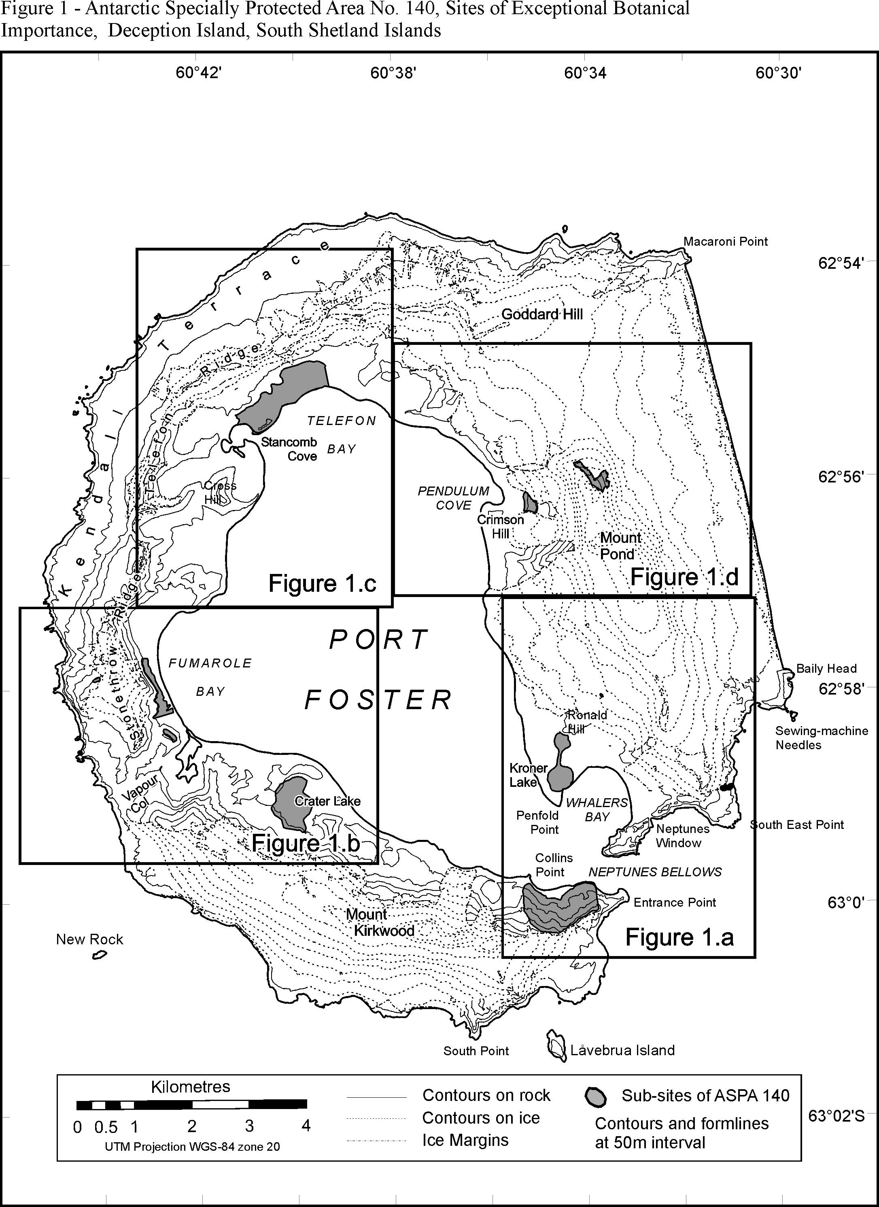
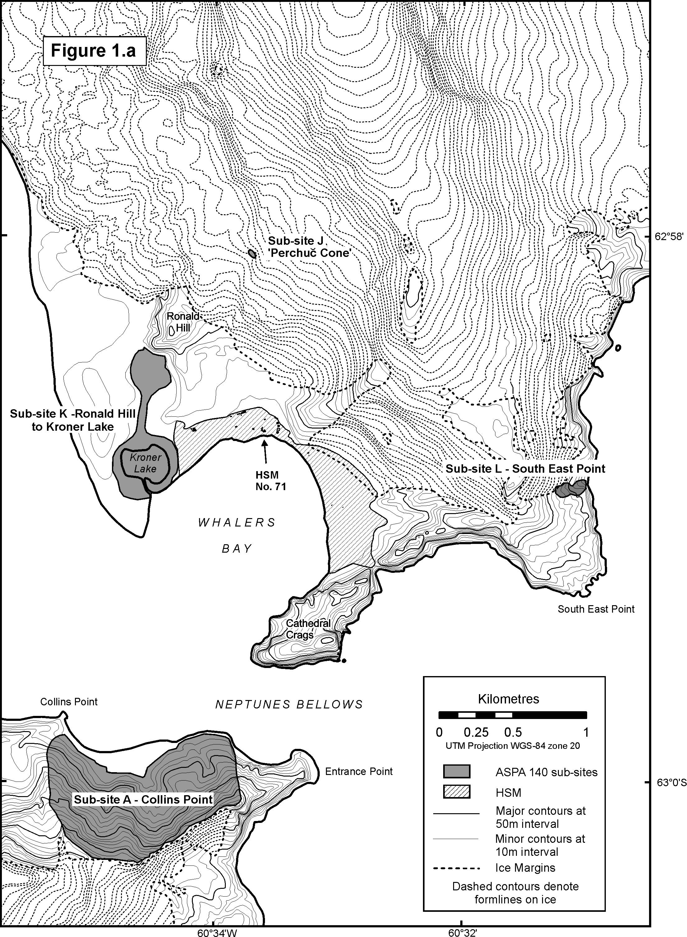

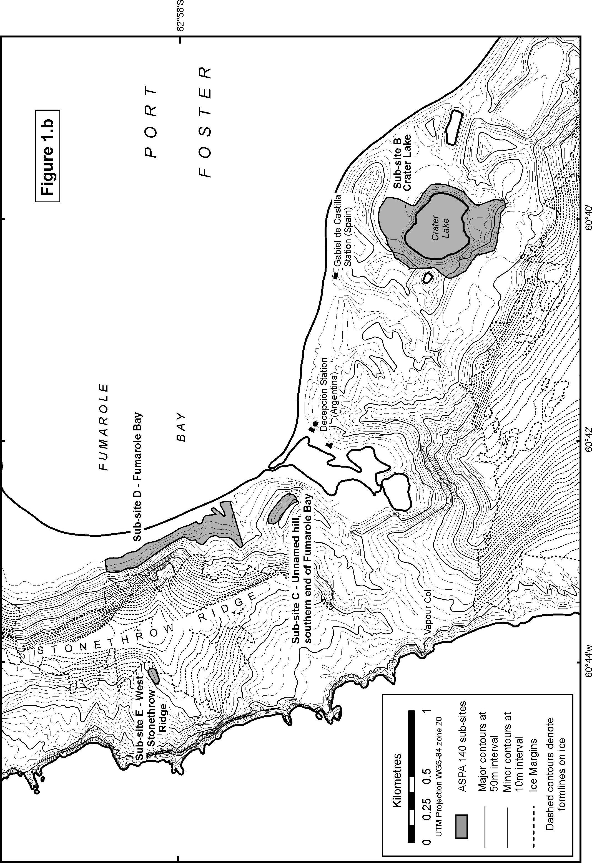

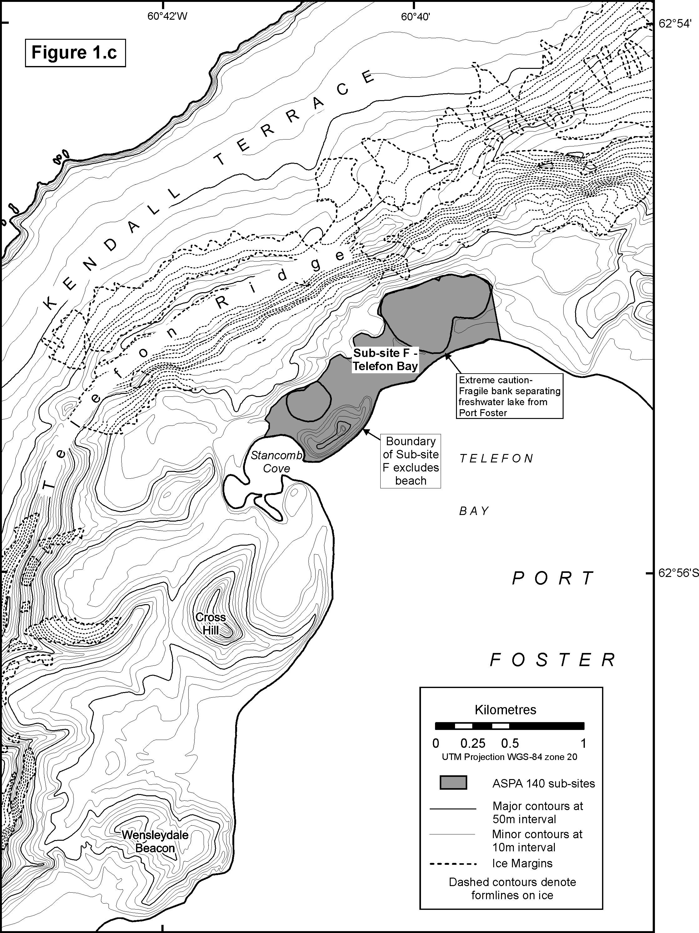
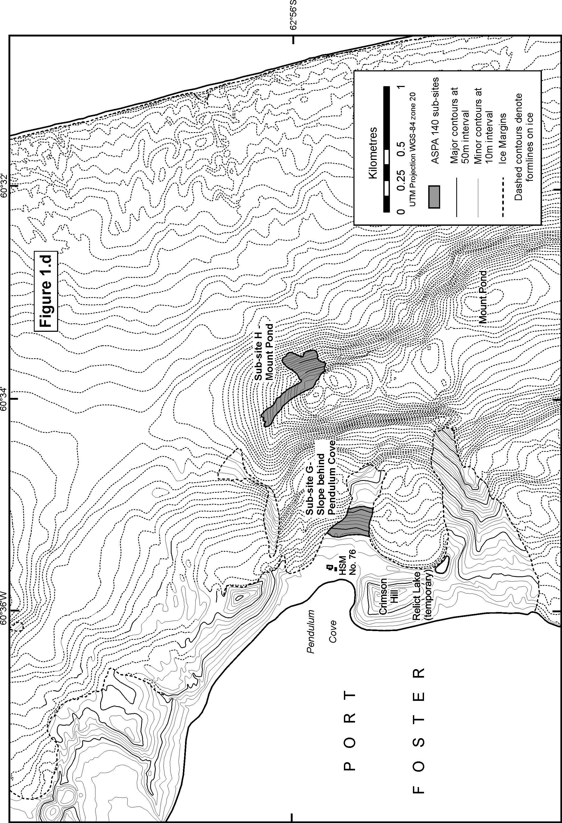

known to grow at a few localities in the Antarctic and often in small quantity
known to grow at only one or two localities in the Antarctic

