Alert Scheme and Escape Strategy for volcanic eruptions on Deception Island

Spanish seismologists monitor seismographs on the island for about three months each year (generally between late November and late February). That period also corresponds to the major period of human activity on the island.

The schematic arrangement presented in Table 1 is adapted from that used by the Alaska Volcano Observatory (United States Geological Survey;

http://www.avo.alaska.edu/avo4/updates/color_code.html).

This type of scheme is well suited to Deception Island.

Masters of vessels intending to enter Deception Island, or pilots of aircraft flying near to the island, should pay attention to any bulletins on the current state of activity of the volcano that are issued from Gabriel de Castilla Station (Spain), or by an appropriate spokesperson representing a national Antarctic programme operating in the Antarctic (e.g. Argentine Antarctic Institute, British Antarctic Survey, National Science Foundation (USA) or Spanish Antarctic Programme).

Table 1. Alert scheme for eruptions on Deception Island (modified after system used by USGS Alaska Volcano Observatory).

Colour code | Alert state | Description
GREEN | No eruption is anticipated. | Volcano is quiet, in dormant state. Normal seismicity and fumarolic activity occurring. This is the normal alert state for Deception Island.
YELLOW | An eruption is possible in the next few weeks and may occur with little or no additional warning. | Volcano is restless; an eruption may occur. Increased levels of small earthquakes detected locally and/or increased volcanic gas emissions.
ORANGE | Explosive eruption occurring or is possible within a few days and may occur with little or no warning. Ash plume(s) not expected to reach  10 000 m above sea level. | Volcano in eruption, or eruption may occur at any time. Increased numbers and/or magnitudes of local earthquakes. Extrusion of lava flows (non-explosive eruption) may be occurring.
RED | Major explosive eruption is in progress or expected within 24 hours. Large ash plume(s) expected to exceed 10 000 m above sea level. | Significant eruption is occurring or major explosive activity expected at any time. Strong earthquake activity detected even at distant monitoring stations.

Escape strategy in case of a volcanic eruption on Deception Island

This escape strategy is based on the premise that eruptions will be similar to those documented in 1967-1970, i.e. with a limited geographical impact on the island (code orange alert state; Table 1). A sudden collapse of the caldera could result in a much more serious eruption, with potentially devastating effects on anyone on the island at the time. Escape from the island during a caldera collapse eruption is unlikely. However, the probability of this is very low and it would likely be preceded by significant precursory activity, particularly widespread ground inflation and associated earthquakes, during several days or weeks prior to the eruption. However, any eruptions can take place with relatively little immediate warning.

- Inner coast areas are likely to be hazardous because of ash fall, possible pyroclastic surges (within c. 2 km of an eruption centre), tsunami and irregular rapid tidal oscillations. Tidal effects are likely to be pronounced by water ramping onto beaches, and they may prevent the use of inner coast beaches for boat uplift. People may therefore have to be uplifted from the outer coast.
- If ships are present within Port Foster when an eruption occurs, they should depart the island immediately, ideally after uplifting all people ashore. Masters of vessels should observe extreme caution whilst departing Neptunes Bellows because of tidal rips and surges, which are enhanced at the narrow shallow entrance channel. Masters of vessels should also be aware of Ravn Rock, which is located at Neptunes Bellows, and the possibility of rockfalls from Cathedral Crags.
- All rescuing vessels and helicopters should avoid passing through or under the eruption clouds because of the damaging effects of gritty ash particles on machinery.
- Escape routes to the outer coast of the island are shown in Figure 1 of Appendix 6. All escape routes from the inner bay to the outer coast are strenuous, both climbing up onto the caldera rim and (in most cases) descending again on the outside. The caldera wall is steep (impassable cliff in places) and covered in highly mobile scree. It is impossible to use ground vehicles (e.g. ATVs) to transport people out of the caldera. Although exit routes are passable for ATVs at two places, much skill and local knowledge of the routes are required and the routes are impassable to ATVs carrying a passenger.
- All routes to the outer coast will take hours to complete, ranging from about 2 hours for the easiest route (Whalers Bay to Baily Head) to 3 or 4 hours (or more) if the unnamed bay on the north coast or at Macaroni Point are the only options. These are minima and based on times likely to be taken by young relatively fit persons. The routes are physically arduous as most surfaces are yielding (mainly composed of coarse ash and lapilli). Exhaustion is likely and should be anticipated, even in fit persons. Descending to beaches on the outer coast is also generally difficult because of steep slopes. Apart from routes shown from Goddard Hill to Macaroni Point and the unnamed bay on the north coast (Figure 1), there are no recommended safe routes over snow and ice. Because of important difficulties peculiar to glaciers (e.g. crevasses, whiteout, slippery surfaces), other glacier travel should be avoided unless with trained guides using suitable equipment (e.g. ice axes, ropes, harnesses). Such equipment is unlikely to be readily available in an emergency.
- Helicopter uplifts may be the best option as most of the outer coast beaches are narrow, bouldery and shelve steeply into deeper water, causing beach surf even on calm days. Some beaches (e.g. north of Punta de la Descubierta) also have a submerged offshore bar hazardous to small boats. If wind conditions are suitable, it may be possible to uplift people by helicopter from the inner coast. The most appropriate action can be judged at the time. Although helicopter uplifts can probably be effected, with variable difficulty, almost anywhere, the best areas are shown in Figure 1 of Appendix 6.

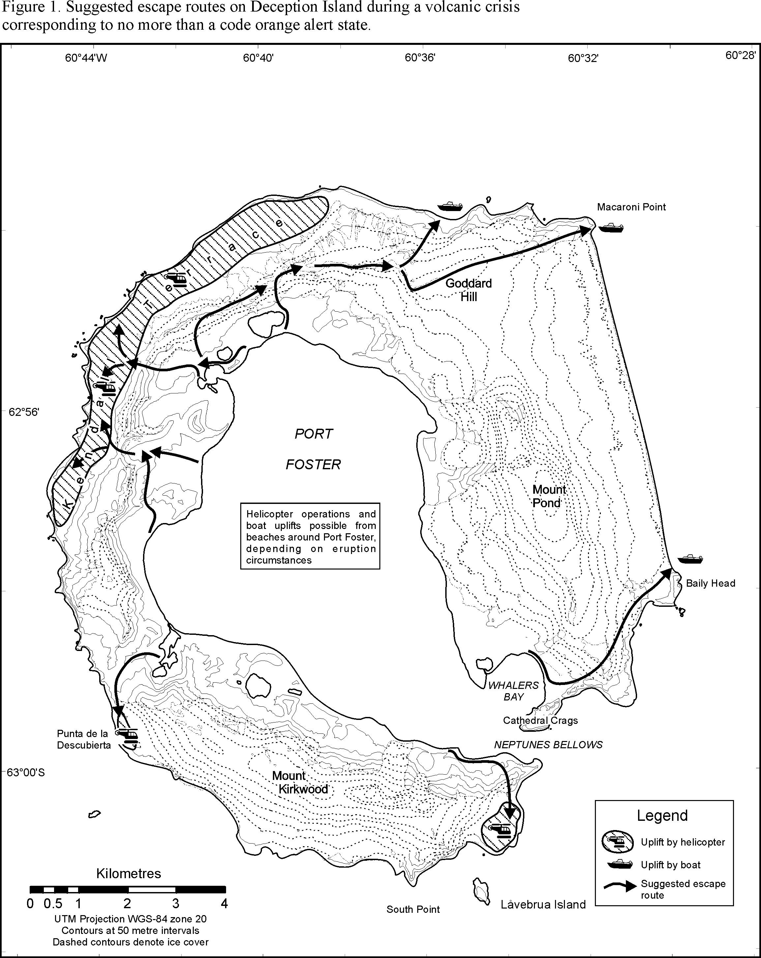

Adapted from Smellie, J.L. (2002) Volcanic Hazard. In: Smellie, J.L., López-Martínez, J., Headland, R.K., Hernández-Cifuentes, Maestro, A., Miller, I.L., Rey, J., Serrano, E., Somoza, L. and Thomson, J.W. 2002. Geology and geomorphology of Deception Island, 78 pp. BAS GEOMAP Series, Sheets 6-A and 6-B, 1:25,000, British Antarctic Survey, Cambridge.

