Conservation Strategy for Historic Site and Monument No. 71, Whalers Bay, Deception Island

1. Introduction

1.1 General background

Historic Site and Monument No 71, Whalers Bay (latitude 62° 59’S, longitude 60° 34’W), is located on Deception Island, South Shetland Islands, Antarctica.

The buildings, structures and other artefacts on the shore of Whalers Bay, which date from the period 1906-1931, represent the most significant whaling remains in the Antarctic. Other buildings, structures and artefacts of the British ‘Base B’ represent an important aspect of the scientific history of the area (1944-1969).

The remains of the Norwegian Hector whaling station at Whalers Bay were originally listed as Historic Site and Monument No. 71 in ATCM Measure 4 (1995) based on a proposal by Chile and Norway. The extent of the historic site was expanded in 2003 by means of ATCM Measure 3 (2003) (see Section 3).

1.2 Brief historical background (1906-1969)

During the 1906-07 austral summer, the Norwegian Captain Adolfus Andresen, founder of the Sociedad Ballenera de Magallanes, Chile, began whaling at Deception Island. Whalers Bay served as a sheltered anchorage for factory ships that processed whale blubber. In 1908 a cemetery was established here. The cemetery was partly buried and partly swept away during a volcanic eruption in 1969, at which time it comprised 35 graves and a memorial to ten men who were lost at sea (only one body was recovered). In 1912, a Norwegian company, Aktieselskabet Hektor, established the shore-based whaling station in Whalers Bay. Hektor whaling station operated until 1931.

During the 1943-44 austral summer, the UK established a permanent base (Base B) in part of the abandoned whaling station. Base B was operated as a British scientific station, latterly by the British Antarctic Survey, until 1969, when it was severely damaged by a mud and ash flow caused by a volcanic eruption, and was abandoned.

The Attachment A contains further detail on the history of Whalers Bay, including a bibliography.

1.3 Aim and objectives of the conservation strategy

The overall aim of the conservation strategy is to protect the values of Whalers Bay Historic Site. The objectives are to:

- Maintain and preserve the cultural heritage and the historic values of the site within the constraints of natural processes. Minor restoration and conservation work will be considered, whilst it is recognised that natural processes will continue to cause the deterioration of buildings, structures and other artefacts over time.

- Prevent unnecessary human disturbance to the site, its features and artifacts. Every effort shall be made to ensure that human activity at the site does not diminish its historic values. Any damage, removal or destruction of buildings or structures is prohibited in accordance with Article 8 (4) of Annex V to the Protocol on Environmental Protection to the Antarctic Treaty.

- Permit ongoing clean up of debris. Large quantities of waste are present in and around the buildings at Whalers Bay. Wind-scattered debris is present throughout the site. There is also hazardous waste present, including diesel fuel and asbestos. A major clean up of loose debris and waste, identified by conservation and environmental experts as not forming an important part of the historic remains, was undertaken in April 2004. Furthermore, a program of ongoing clean–up of debris resulting from the gradual deterioration of the structures, will be instigated.

- Educate visitors to understand, respect and care for the historic values of the site. Whalers Bay Historic Site is one of the most visited sites in Antarctica. Information on the historic significance of the site, and the need to conserve its values, will be made available to visitors.

- Protect the natural environment of the site. Whalers Bay is an integral part of the unique natural environment of Deception Island. Activities at the site should be undertaken in such a way that minimises any environmental impact.

2. Parties undertaking management

Chile, Norway and the UK shall consult within the wider Deception Island Management Group to ensure that the provisions of this conservation strategy are implemented and its aim is met.

3. Description of the site

The site comprises all pre-1970 remains on the shore of Whalers Bay, including those from the early whaling period (1906-12) initiated by Captain Adolfus Andresen of the Sociedad Ballenera de Magallanes, Chile; the remains of the Norwegian Hektor Whaling Station established in 1912 and all artefacts associated with its operation until 1931; the site of a cemetery with 35 burials and a memorial to ten men lost at sea; and the remains from the period of British scientific and mapping activity (1944-1969). The site also acknowledges and commemorates the historic value of other events that occurred there, from which nothing remains.

3.1 Site boundary
Figure 1 shows the boundary of the Whalers Bay Historic Site. It comprises most of the beach at Whalers Bay from Neptunes Window to the former BAS aircraft hangar. Boundary markers, which would detract from the aesthetic value of the site, have not been erected. Figure 1 also shows the major historic buildings and structures at the site.

3.2 Historic remains
Table 1 summarises the main buildings, facilities and other structures at the site. More detailed information about these historic structures is provided in Attachment B and their location is shown on Figure 1.

Table 1: Historic remains at the Whalers Bay Historic Site
# | Structure |  |  | Map 1
Whaling period

WB1 | Various remains from the whaling period at Deception Island (1906-1931), including:  - Water boats and rowing boats  - Wells and well head houses  - Storage building  - Wooden and metal barrels  - Rampart dams |  |  | 14
WB2 | Cemetery (1 cross and 1 empty coffin currently visible) |  |  | Cross
WB3 | Magistrate’s residence |  |  | 3
WB4 | Hospital/storage building |  |  | 2
WB5 | Boilers |  |  | 7
WB6 | Cookers and associated equipment, including:  - cooking grills  - driving wheel  - steam winch |  |  | 7
WB7 | Foundation of kitchen/mess building (subsequently reused as the foundations for Priestley House) and piggery |  |  | 4
WB8 | Fuel storage tanks |  |  | 10, 11
WB9 | Half floating dock |  |  | 12
WB10 | Whalers Barracks (subsequently renamed Biscoe House) |  |  | 5
Scientific period

WB11 | ‘Hunting Lodge’ (UK company Hunting Aerosurveys) |  |  | 9
WB12 | Aircraft hangar |  |  | 1
WB13 | Massey Ferguson tractor |  |  | 6

Natural environment

The 1967 volcanic eruption on Deception Island resulted in the deposition of a 1-5 cm layer of ash over Whalers Bay, whilst the 1969 eruption caused a lahar (mud slide) which partly buried the site. Geologically important, and fragile fluvial terraces are located to the north of the whaling station.

The immediate area to the west of the Historic Site, including Kroner Lake, the Ronald Hill crater plain and the valley connecting them, is designated as part of ASPA 140 due to its exceptional botanical and limnological importance.

Further areas of botanical importance are located within the Historic Site. These include a geothermally active scoria outcrop to the east of the whaling station, around the ‘Hunting Lodge’, inside the two accessible whale oil tanks, around the site of the cemetery, and on the cliffs and massive boulders at Cathedral Crags and Neptunes Window. Elsewhere, timber and iron structures, bricks and mortar, are colonised by various crustose lichens, all of which are common on natural substrata on the island.

Kelp gulls (Larus dominicanus) and Antarctic Terns (Sterna vittata) breed at Whalers Bay, and Cape petrels (Daption capensis) nest in Cathedral Crags, overlooking the site.

Management of the site

4.1 Access to, and movement within, the site

- The recommended landing site is directly in front of the whalers’ boilers (see Figure 1).

- Motorized vehicles are only to be used within the HSM for scientific, conservation or clean-up activities (e.g. removal of waste).

- Access to buildings or other structures including boilers and tanks, is prohibited unless for management purposes, or for shelter in an emergency.

- Helicopter landings, where necessary for conservation or management purposes, should only take place in the designated landing site (shown in Figure 1) to avoid dangers associated with loose debris and to prevent damaging structures or causing disturbance to wildlife.

- Field camps for scientific or management purposes should be established in the area to the east of the half floating dock as indicated in the map provided in Attachment B. The use of buildings for camping purposes is prohibited except in an emergency.

Installation, modification and removal of structures

- In accordance with Article 8 of Annex V to the Protocol on Environmental Protection to the Antarctic Treaty (1998), the historic structures, facilities and artefacts at the site are not to be damaged, removed or destroyed. Graffiti considered to be of historic importance should not be removed. New graffiti should not be added.

- Conservation and/or restoration work agreed by the Parties undertaking management may be carried out. Work on the buildings and structures may be necessary to render them safe or to prevent damage to the environment.

- No new buildings or other structures (apart from interpretative material agreed by Chile, Norway and the UK, in consultation with the wider Deception Island Management Group) are to be erected at the site.

- Historic remains and artefacts found at other locations on Deception Island, or elsewhere, which originate from Whalers Bay may be returned to the site after due consideration by those Parties undertaking management.

4.3 Visitor guidelines

The general guidelines, outlined in Code of Conduct for Visitors to Deception Island, apply to all visitors, including visits by commercial tour operators (IAATO and non-IAATO affiliated), private expeditions and National Antarctic Programme staff when undertaking recreational visits. In addition, the following site-specific guidelines apply:

- Stay on the seaward side of the station remains, the water boats, and the piles of barrel staves, in order to avoid the geologically important, and fragile, fluvial terraces located to the north of the whaling station.

- Do not go beyond the western end of the airplane hangar in order to avoid entry into ASPA 140 (Site K).

- Do not enter buildings or tanks or sit or climb on the boats.

- Approach oil and fuel tanks with caution. The foundations are vulnerable to erosion and the tanks are at risk of collapse.

- Beware of flying debris in windy conditions.

- Visitors to Neptunes Window should proceed along the beach on the seaward side of the waterboats. They should then walk up the slope towards the ‘window’ in single file and remaining on existing paths. Extreme caution should be exercised along the steep and friable edge of Neptunes Window. Follow existing paths back down to the beach. Visitors should not attempt to traverse the scree slope to the south, below Cathedral Crags, which is susceptible to rockfalls.

4.4 Information

- An informative sign, agreed by the Parties undertaking management, will be located at the recommended landing site. Appropriate and necessary signs advising visitors of any health and safety issues will also be considered.

- Memorial plaques (e.g. listing the names of those buried in the cemetery, or commemorating Captain Adolfus Andresen) may also be located within the site.

- Boundary markers are not considered necessary, as they would detract from the aesthetic value of the site. The boundary generally follows clearly visible natural features.

- The Parties undertaking management will disseminate further information about the significance of the historic site and the need to conserve its values.

Reporting

The following records are to be maintained by the Parties undertaking management:

- number of tourists landing at the site;
- number of scientists and associated logistics personnel visiting the site;
- conservation and clean-up work carried out; and
- site inspection reports, including reports and photographs on the condition of the historic remains.
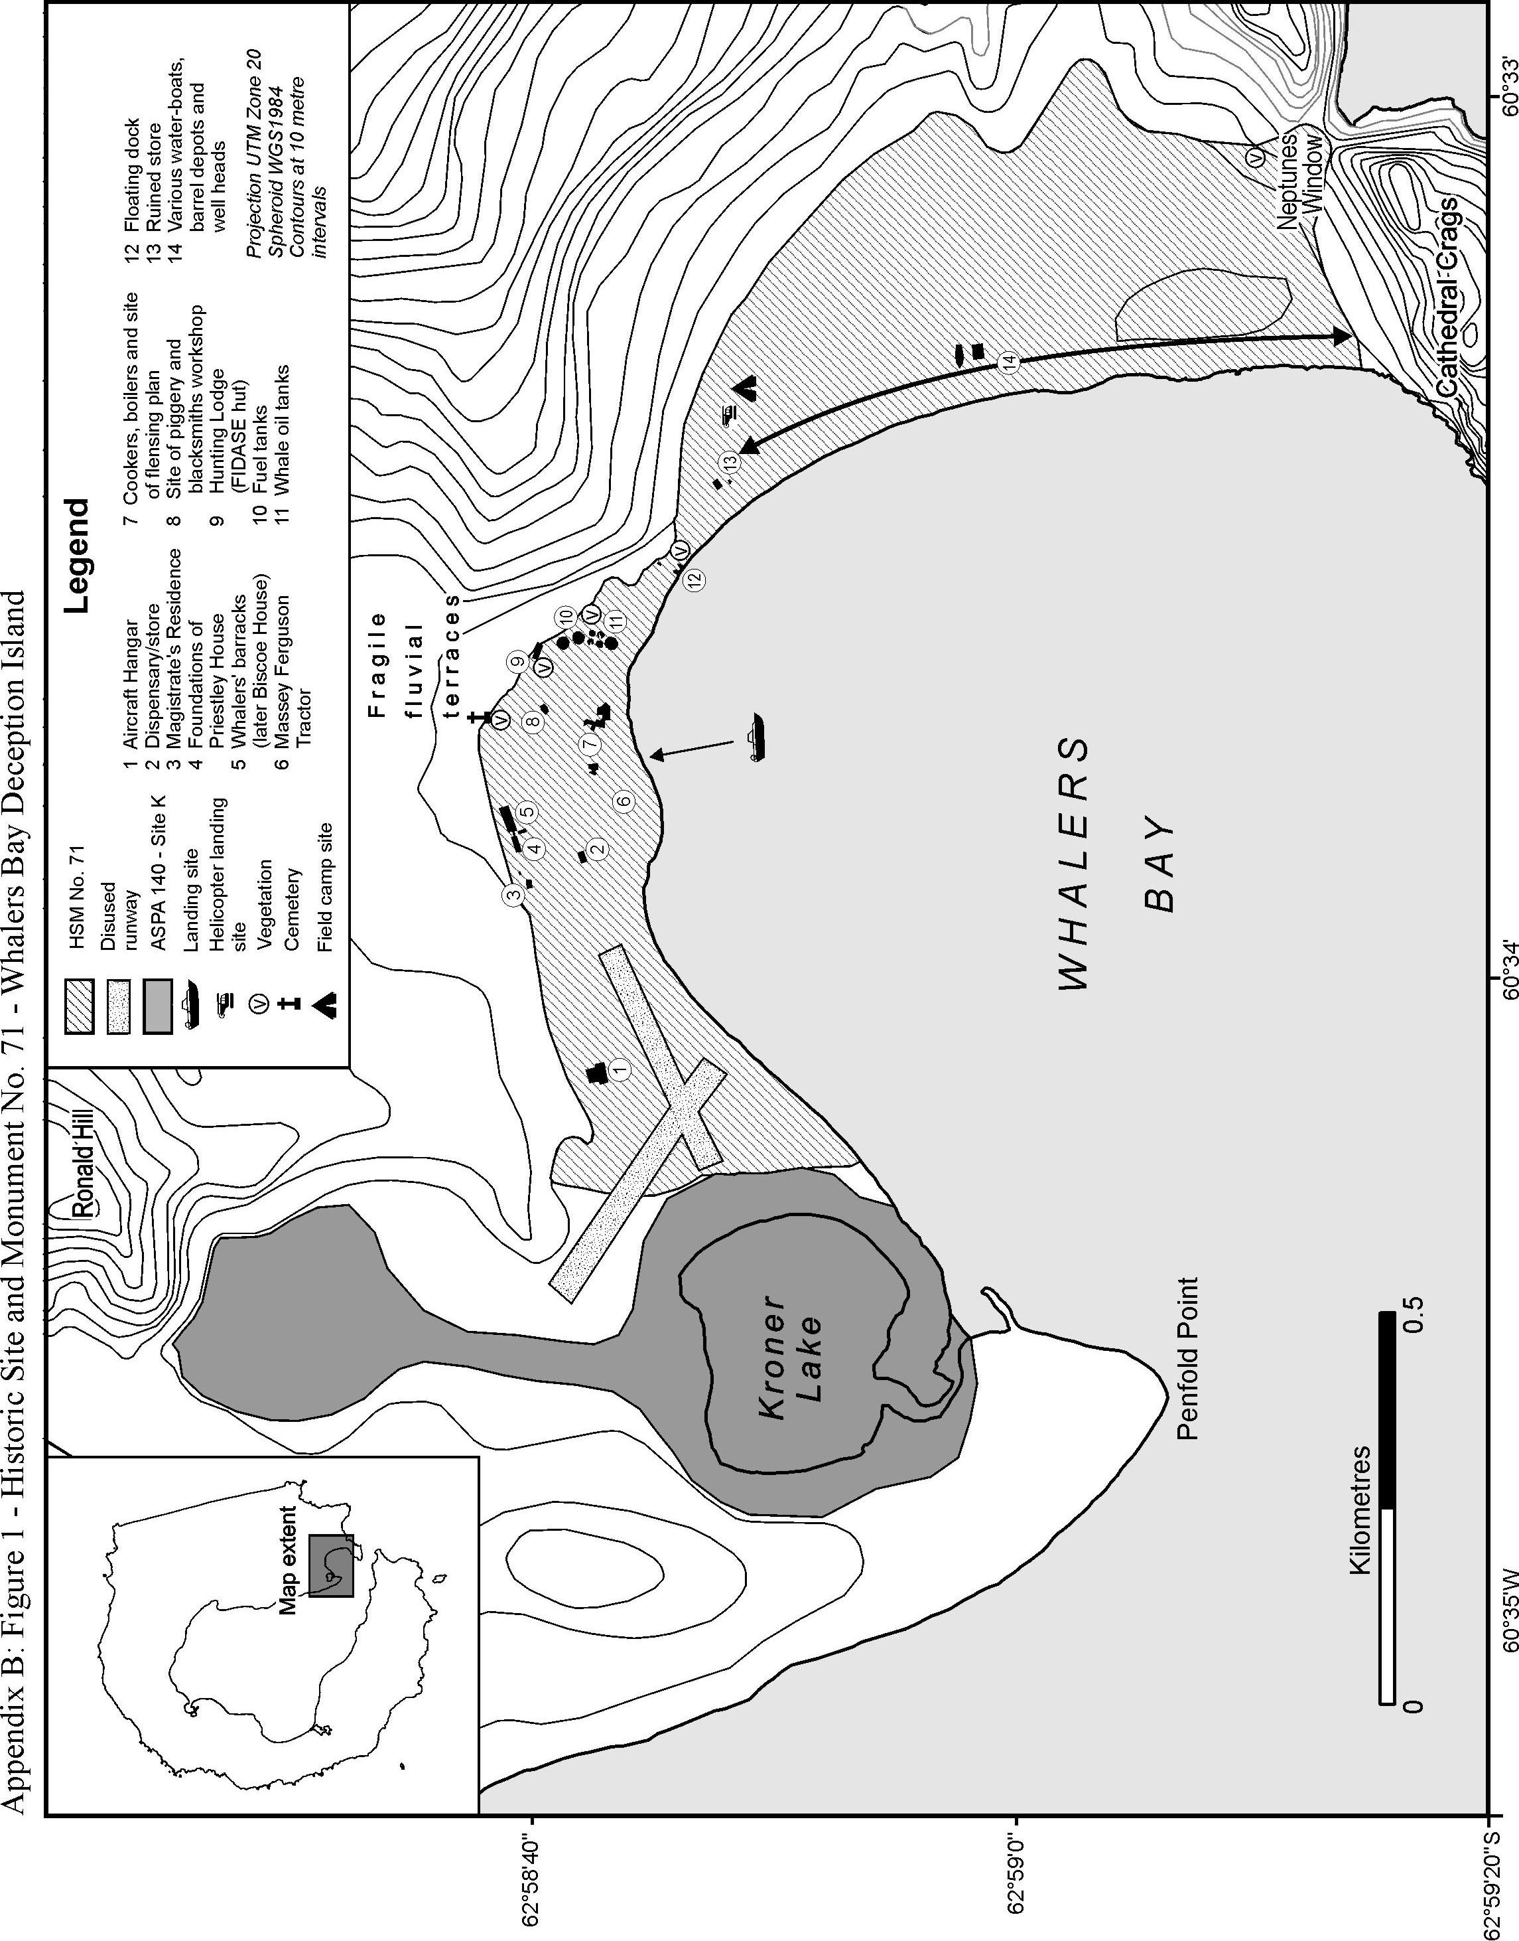

Reference number is cross-referenced with the information in Attachment B.
Reference to map location (Figure 1)
A de Havilland DHC-3 Single Otter was removed from the site in April 2004 by BAS for safe-keeping. The intention is to return it to Whalers Bay once it is safe to do so.

